**Chapter 1**

**8086 Architecture**

1. **Pin Diagram of 8086:**

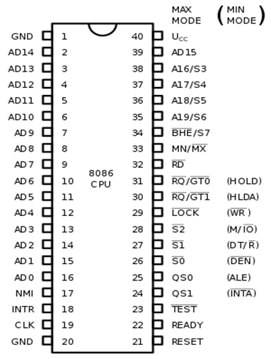

1. **Architecture of 8086:**

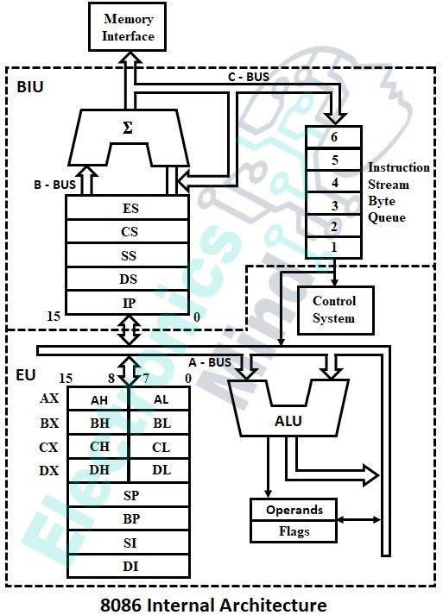

1. **Use of Status Signals in Maximum Mode:**

|  |  |  |  |
| --- | --- | --- | --- |
| **S2** | **S1** | **S0** | **Status** |
| 0 | 0 | 0 | Interrupt Acknowledge |
| 0 | 0 | 1 | I/O Read |
| 0 | 1 | 0 | I/O Write |
| 0 | 1 | 1 | Halt |
| 1 | 0 | 0 | Opcode Fetch |
| 1 | 0 | 1 | Memory Read |
| 1 | 1 | 0 | Memory Write |
| 1 | 1 | 1 | Passive |

1. **Features of 8086:**
2. It is 40 pin IC.
3. HMOS technology is used.
4. 5V DC supply required.
5. 16-bit Data Lines.
6. 20-bit address line hence can address 220=1MB.
7. Operating clock frequency is 5MHz, 8MHz, 10MHz.
8. Multiplexed address and data lines (AD0 - AD15).
9. It can perform arithmetic operations like addition, subtraction, division, multiplication and logical operations like AND, OR, NOT.
10. 8086 have 6-bytes instruction queue (IQ).
11. Parallel or pipelining execution of BIU and EU.
12. It provides 256(28) software interrupts and two hardware interrupts (NMI and INTR).
13. It can access 216 = 64 kilo I/O devices (56536 I/O Devices).
14. It supports multiuser, multiprogramming due to memory segmentation.
15. It consists of four segments as

* Code Segment
* Data Segment
* Stack Segment
* Extra Segment

1. It provides separate instruction set for string operations.
2. Powerful instruction set, can be programmed using high level language like c.

**Chapter 2**

**Assembly Language Programming**

To develop an assembly language program, we must know the program development steps such as defining and understanding the problem, and then represent it using standard way of algorithm or flowchart. Then the next step is the coding that actually develops the program.

To develop the assembly language program, we have to use different assembly language programming tools like editor, assembler, linker, and debugger.

The editor is used to create the source code which is further converted into an object code (.obj) by an assembler. This is called as assembling the program. Then from that object code, the executable code (.exe) is generated by a linker, so that the program can be run by the CPU. This is called as linking of the program. And finally, debug the program to find out the error, if any and troubleshoot these errors using the debugger.

For each type of language, there is a specific structure in which the source code of that particular language is to be developed and written. In the same way, to develop an assembly language program with assembler, we have to follow the specific structure of assembly language programming.

In order to edit, assemble, and link the program to create the executable code which is ready to run, we have to follow a specific sequence of steps provided by the structure of the programming language. This structure is called as model of 8086 assembly language program.

**Model (Structure) of 8086 Assembly language Programs: -**

1. To develop an assembly language program by following specific format and syntax, we have to use an assembler tool that may be either TASM (Turbo Assembler) or MASM (Microsoft Assembler).
2. This consists of Assembler Directives, 8086 Assembly Language Instructions and Data, written in specific sequence and format.
3. There are three different models of Assembly Language Program, and they are as follows —

# Assembly Language Programming Model using SEGMENT and ENDS Directives

* 1. **Assembly Language Programming Model using . (Dot) Directive**

# Editing, Assembling, and Linking the Assembly Language Program

A)



1) This model uses different logical segments for data and variable declarations and initialization as well as for writing instructions.

z) We can use single or multiple code and data segment to develop the

assembly language program.

1. Each logical segment starts with a SEGMENT directive and end with an ENDS directive, and both are followed by the name of segment.
2. The format (structure) is as follows — DATA SEGMENT

<VARIABLE DECLARATION STATEMENTS> VAR1 DB ......

YAR1 DW .....

DATA ENDS CODE SEGMENT

ASSUME CS:CODE, DS:DATA START:

<ASSEMBLY LANGUAGE INSTRUCTIONS / EXECUTABLE STATME>

<PROCEDURES / MACROS>

CODE ENDS END START

1. The program starts with a declaration of logical data segment using the SEGMENT assembler directive.
2. This data segment consists of all variable declarations along with data initialization. It does not contain any assembly language instruction.
3. The data segment ends with a ENDS assembler directive.
4. Then the logical code segment is started with SEGMENT assembler directive.
5. This segment consists of ASSUME assembler directive, that indicates the name of the logical segment along with physical segment register.
6. After this, a label START is used, which indicates the entry point of the program execution. In other words, the execution of assembly language instructions starts from this label.
7. The logical code segment consists of assembly language instructions, procedures, and macros. It does not contain the any variable declarations and data initialization part.

12) This segment ends with an ENDS assembler directive.

13) After this ENDS directive, there is one more assembler directive known as END assembler directive that indicates end of the program. No other statement (instruction) is added (used) after an END directive (Except comment, if required).

B) 

1. This model is somewhat different than the SEGMENT and ENDS model.
2. It is used when the program uses a single code and single data segments in memory which is tiny or small.
3. Here, the data segment starts with a .DATA (dot DATA) directive, and code segment starts with a .CODE (dot CODE) directive.
4. This code segment ends with .EXIT directive. The use of .EXIT directive is optional.
5. END assembler directive is used to indicate end of the program. No other statement (instruction) is added (used) after an END directive (Except comment, if required).



1) For writing and executing an assembly language program as per above models, we need to use different tools for editing, assembling, linking, and debugging a program.

z) These tools are provided by a MASM or TASM assembler tools. Let us see, how the program is written and executed using these tools.

a) 

1. For writing a new program, or editing an existing program, we need to use a tool called **EDITOR.**
2. We know that, an editor is a system program which allows us to create and edit a source file as per standard structure.
3. To use an editor tool in DOS system, we use an **EDIT** command with the name of program (file) as follows —

C:\MASM> EDIT PNAME.ASM ;using MASM OR C:\TASM> EDIT PNAME.ASM ;using TASM

1. Using this command, an editor is opened. Then type the program and save it and then exit from the editor. Note that the program is saved in secondary memory at specified location with name PNAME and an extension .ASM.

b) 

1) After editing, the next step is to assemble the program using another tool called as an **ASSEMBLER.**

1. No need to use the ASSUME directive in this model, since the segments are automatically associated with their physical segment registers.
2. The format of this model is as follows —

.MODEL SMALL

.DATA

<VARIABLE DECLARATION STATEMENTS> YAR1 DB ......

YAR1 DW .....

.CODE

.STARTUP START

<ASSEMBLY LANGUAGE INSTRUCTIONS / EXECUTABLE STATMENTS>

<PROCEDURES / MACROS >

EXIT END

1. The program starts with a declaration of logical data segment using the

.DATA assembler directive.

1. This data segment consists of all variable declarations along with data initialization. It does not contain any assembly language instruction.
2. The data segment ends automatically when code segment starts using

.CODE assembler directive.

1. After this, a .STARTUP is used, which indicates the entry point of the program execution. In other words, the execution of assembly language instructions starts from this label.
2. The logical code segment consists of assembly language instructions, procedures, and macros. It does not contain the any variable declarations and data initialization part.
3. An assembler is a system program that converts the source file provided by an editor into an object file. This process is known as assembling of program.
4. To do this, we use the following command for assembler — C:\MASM> MASM PNAME.ASM ; using MASM OR C:\TASM> TASM PNAME.ASM ; using TASM
5. If there are no errors then the object code is created by an assembler with name **PNAME.OBJ.** Then next step is to link the program using LINKER.
6. If there are errors, then first correct these errors using editor as per above mentioned editor command, save it and exit, then again assemble the program. Note that, no object code is created if the program has errors.
7. Repeat this process unless the error count becomes zero. Then process for next step i.e. linking of program. Note that, the object file is generated at the same location where the source file is stored, i.e. in secondary memory.
8. **Linking a Program:** -
   1. After assembling the program, the next step is linking the program using one more tool called a **LINKER.**
   2. A linker is a program that joins several object files into one large object file and converts this object file provided by an assembler into an executable file with extension .EXE. This process is called as linking of a program.
   3. To use a linker (for linking), we use a command as —

C:\ MASM> LINK PNAME.OBJ ; using MASM OR C:\TASM> TLINK PNAME.OBJ ; using TASM

* 1. After this command, the linker generates an executable file with extension

**.EXE,** and the complete name of the file is **PNAME.EXE.**

* 1. Note that, the EXE file is also generated at the same location in secondary memory, where the source file and an object file is stored. The next step is to process that file with the debugger.

d) 

1j After generating an EXE file by the linker, the next and final step is to process that EXE file with system program known as **DEBUGGER** for execution.

1. The EXE file is stored in secondary memory, and for executi0n, that file must be loaded into main memory. This is done by a debugger.
2. A debugger is a system program that loads the program from secondary memory into main memory for the purpose of execution. It also starts the execution of the program.
3. A debugger allows us to debug a program. It also allows us check memory location contents, CPU register contents at run time. It also troubleshoots the errors, if any.

 To use the debugger, the command used is -

C:\MASM> DEBUG PNAME.EXE ; using MASM OR

C:\TASM> TD PANEM.EXE ; using TASM

1. Using these commands, the execution of the program is started. If we use the MASM, then after this command a ’—’ is displayed at the next line, indicating that the DEBUG operation is successfully invoked, and further use the debug prompt for debugging commands.
2. A valid command is accepted using the enter key. Some of the commands that we use for debugging are ’T’, 'D’, ’R', and ’q’ for tracing program execution, displaying memory contents in segment from specified offset, displaying all registers and flags, and quit the debug and return to DOS respectively.

**Chapter 3**

**Program**

1. **Algorithm:**

**Step 1:** Initialize Data Segment

**Step 2:** Initialize Hex_Num with 0

**Step 3:** Initialize Multi_fact with 1000

**Step 4:** Initialize Digit_Count with 4 in CX

**Step 5:** Initialize Memory Pointer to read Digits of BCD Number in SI

**Step 6:** Read Digit of BCD Number using memory pointer in SI

**Step 7:** Multiply Digit by Multi_fact, Result in AX

**Step 8:** Hex_Num = Hex_Num + AX [i.e Result of Multiplication]

**Step 9:** Divide Multi_fact by 10

**Step 10:** Increment Memory Pointer SI by 1

**Step 11:** Decrement Digit Counter by 1 to read next Digitof BCD Number.

**Step 12:** Is counter =0?, if True then goto 6, if Fasle then goto 13

**Step 13:** Stop

1. **Flowchart:**



1. **Code:**

.MODEL SMALL

.DATA

BINARY DW 1234H

HEX_NUM DW 0

MULT_FACT DW 3e8h

DIGIT_COUNT DW 4

.CODE

MOV AX,@DATA ;Initialize Data Segment

MOV DS,AX

MOV BX,10 ;Initialize Division Factor

MOV CX,DIGIT_COUNT ;Digit Counter

MOV SI,OFFSET BINARY ;Initialize Memory Pointer

UP:

MOV AL,[SI] ;Read Digit of BCD Number

AND AX,000FH ;Mask Required Digit

MUL MULT_FACT ;Multiply by Multiplication Factor

ADD HEX_NUM,AX ;Add to HEX_NUM

MOV AX,MULT_FACT ;Change Multiplication Factor

MOV DX,00

DIV BX

MOV MULT_FACT,AX

INC SI ;Increment Memory Pointer

LOOP UP ;Is a Last Digit if no Jump to UP

MOV AH,4CH

INT 21H

ENDS

END

1. **Output:**

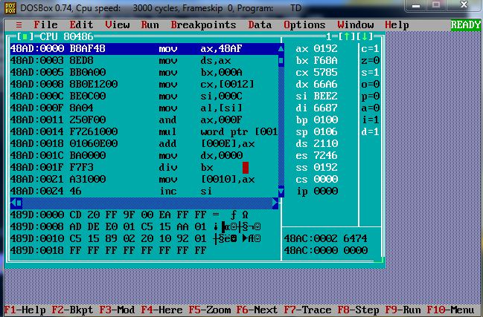

**Chapter 4**

**CO’s, PO’s, PRO’s**

1. **Course Outcome (COs):**

a. Analyse the functional block diagram of 8086.

b. Write assembly language program for the given problem.

c. Use instructions for different addressing modes.

d. Develop assembly language program using assembler.

e. Develop assembly language program procedures, macros and modular programming approach.

1. **Practical Outcome (POs):**
2. Basic knowledge: Apply knowledge of basic mathematics, sciences and basic engineering to solve the broad-based Electronics related problems.
3. Discipline knowledge: Apply Computer Programming knowledge to solve broad-based Electronics related problems.
4. Experiments and practice: Plan to perform experiments and practices to use the results to solve broad-based Electronics related problems.
5. Engineering tools: Apply relevant Computer programming/electrical technologies and tools with an understanding of the limitations.
6. Individual and teamwork: Function effectively as a leader and team member in
7. diverse/ multidisciplinary teams.
8. Communication: Communicate effectively in oral and written form.
9. Life-long learning: Engage in independent and life-long learning activities in the context of technological changes also in the Electronics engineering and allied industry.
10. **Practical Related Outcomes (PROs):**

* Write ALP to convert BCD to equivalent Hex Number.
* Use instructions for different addressing modes
* Identify the various pins of the given microprocessor
* Use assembly language programming tools.

**Chapter 5**

**References**

1. **Books:**
2. 8086 Architecture and Programming By B.Ram.

Edition: 1st Edition Published in the year 2008.

Publication: Dhanpat Rai Publication.

1. 8086 Architecture By A.P.Mathur.

Edition: 1st Edition Published in the year 1995.

Publication: New Age International Publications.

1. 8086/8088 Microprocessor and Programming by Douglas Hall.

Edition: 1st Edition Published in the year 1999.

Publication: Prentice-Hall of India Pvt.ltd.

1. **Websites:**

[Intel 8086 - Wikipedia](https://en.wikipedia.org/wiki/Intel_8086)

https://en.wikipedia.org/wiki/Intel_8086

[Microprocessor - 8086 Overview (tutorialspoint.com)](https://www.tutorialspoint.com/microprocessor/microprocessor_8086_overview.htm) https://www.tutorialspoint.com/microprocessor/microprocessor_8086_overview.htm